**New Vegan Restaurant in Toronto**

1. **Introduction - Business Problem**

Toronto is a growing city with many opportunities for entrepreneurs and working professionals. Vegan & vegetarian food is on increasing trend in many parts of the word and at this moment there are still many big cities where there is a big potential for restaurants focused on this segment of the market. We consider Toronto offers great opportunities for a vegan restaurant, but which are the best locations for such a restaurant?

The results of this analysis are of interest for entrepreneurs interested to open a vegan restaurant or even to restaurant owners who may enlarge their offer with vegan or vegetarian dishes.

1. **Data Description**

In order to solve the business problem and to offer few good recommendations for a vegan restaurant location we will use two sources of data:

1. Wikipedia for data regarding few demographics of Toronto neighborhoods. The data can be found here:

<https://en.wikipedia.org/wiki/Demographics_of_Toronto_neighbourhoods>

and for each neighborhood contains information regarding population size, population density, average yearly income etc. An extract of the data is presented in the table below.

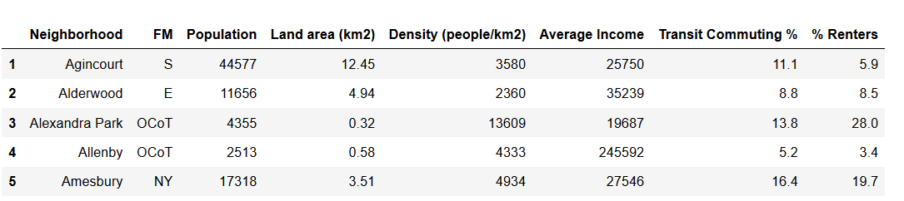

1. Foursquare Developers Access to venue data: <https://foursquare.com/> . By using these data, we will be able to classify each area, to compare how similar or how different areas are with respect to venues, people life style and potential competition.

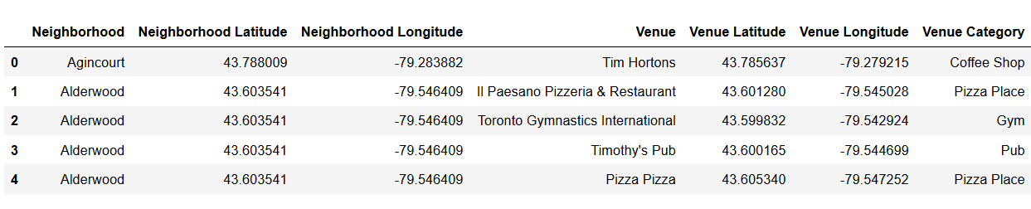

1. **Methodology**

From the demographic data collected from *Wikipedia* we keep the information regarding Neighborhood, Population size, Land area (km2), Density (people/km2), Average Income Transit Commuting (%) and proportion of Renters (%).

We use the *geolocator* in order to obtain the Latitude and the Longitude for each of the 172 neighborhoods. We use python *folium* library to visualize geographic details of Toronto’s neighborhoods as below:

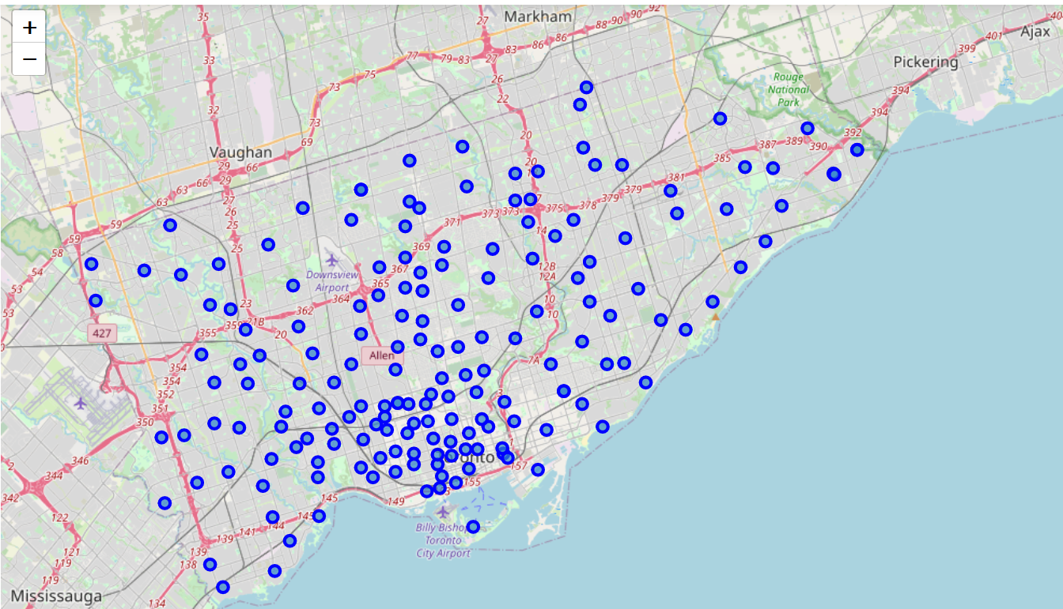

We used the *Foursquare API* to explore the venues of the neighborhoods. We limit the venues of each neighborhood to 100 venues and the radius at 500 m given latitude and longitude information. Here is a head of the list of neighborhoods, venues name, category, latitude and longitude information from *Foursquare API*.

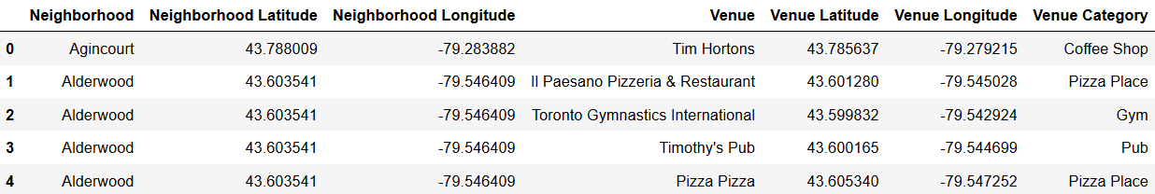

There are in total 3292 venues classified in 311 unique categories. We have found 25 vegan restaurants in Toronto.

In order to find the best locations for new vegan restaurants we put together three types of information:

1. **Classification of the neighborhoods**:

For each neighborhood we put together two types of information – demographics and categories of venues – in order to classify the neighborhoods. For this propose we used unsupervised learning K-means algorithm to cluster the neighborhoods. The final classification has 5 clusters.

1. **Lifestyle in each cluster**:

We assume that specific categories of venues like 'Health Food Store', 'Organic Grocery', 'Vegetarian / Vegan Restaurant', 'Gym / Fitness Center', 'Gym', 'Athletics & Sports', 'Sporting Goods Shop', 'Sports Club', 'Yoga Studio' have higher concentration in areas where people are more interested in a healthy lifestyle.

1. **Competition**:

We will put on the map all the existing vegan restaurants to better visualize their locations.

1. **Results**

The neighborhoods have been classified in five clusters as follows:

1. **Cluster 0** **– red** 🡪 Concentrated on the center of Toronto (with red in the map below), with lots of restaurants and shops and with income over the average. The lifestyle is similar to our interest: many restaurants, organic grocery, sport clubs and gym locations but, on the other hand, competition is high as most of the vegan restaurants are concentrated in this area.
2. **Cluster 1 - purple** 🡪 Covers a big area in mainly in West of Toronto (with purple in the map below), low population density, lowest income and standard/basic venues. Lifestyle: population seems interested in practicing sport but not so much in healthy food.
3. **Cluster 2 - blue** 🡪 Concentrated in three small neighborhoods close to center of Toronto (with blue in the map below), with highest population density and the lowest average income. Lifestyle: low interest in sport and no interest in healthy food.
4. **Cluster 3 - green** 🡪 Big area with low density of population and lowest income (with green in the map below). Lifestyle: sport venues are present but not much interest in healthy food.
5. **Cluster 4 - orange** 🡪 Selective neighborhoods (with orange in the map below) with low population density and the highest average income, much higher than the average. Lifestyle: green areas with many sport lovers but healthy food stores seems to be below expectations for such selective neighborhoods.

In the map below we have the neighborhoods split by clusters’ colors.

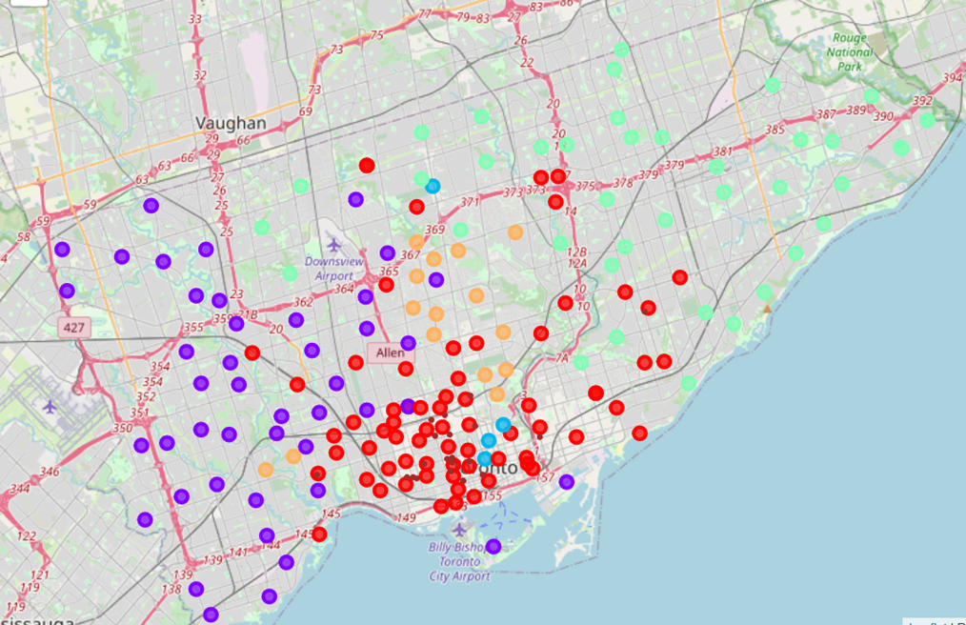

The small brown points represent the existing vegan restaurants

1. **Discussion**

By analyzing the characteristics of the clusters, we observe that two clusters, 0 – red and 4 – orange contains neighborhoods with population much more oriented to a healthy lifestyle as in these areas we find most of the healthy food stores or gym/fitness centers.

There are also two big differences between these two clusters:

1. Cluster 0 – red 🡪 most neighborhoods are located in the center area of Toronto where we see that most of the vegan restaurants are located.
2. Cluster 4 – orange 🡪 the neighborhoods are not so concentrated as in 0-red cluster but the populations has the same lifestyle. In plus, these neighborhoods have a higher standard of life given the much higher income.

It seems that the neighborhoods in the cluster 4-orange are better locations for a new vegan restaurant as the income is much higher and the competition is extremely low

In the map below we added two areas we consider appropriate for new locations for vegan restaurants. The first choice is marked with the yellow circle and the second choice is green circle.

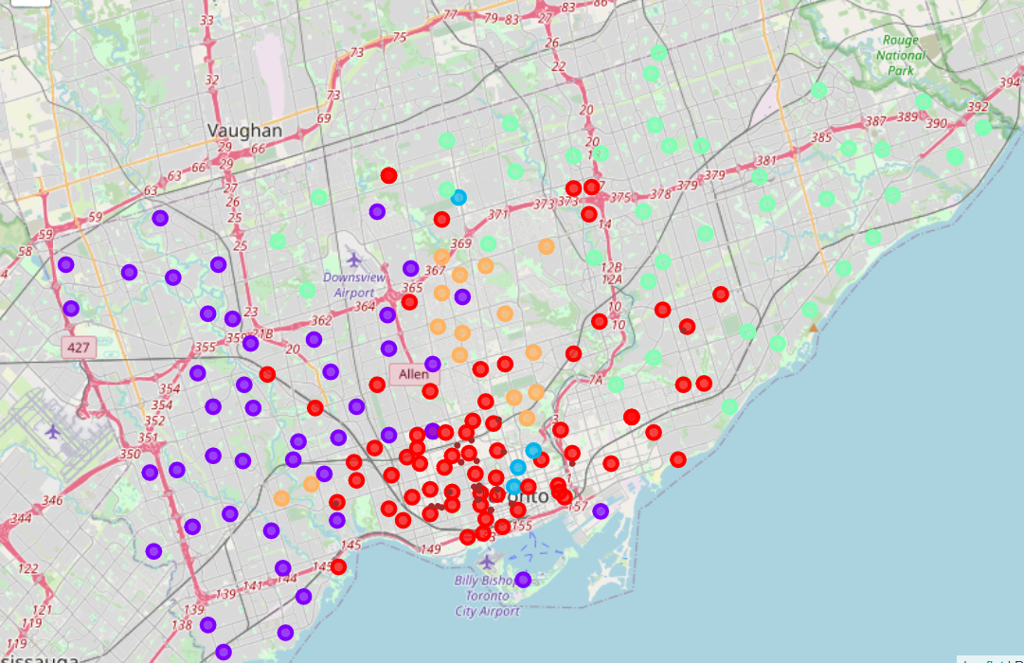

1. **Conclusion**

The neighborhoods of Toronto were analyzed considering demographic characteristics, the venue categories and the lifestyle.

We have found that there are two clusters of neighborhoods which are appropriate for vegan restaurants.

When we consider the existing competition and the average income level the conclusion is clear and we recommended two areas around the neighborhoods of cluster 4-orange in our analysis.